Modeling Information About an Entity
This chapter focuses on modeling information entities and their relationships to real-world entities and information bearers.
Scenario Objective
To model how different types of information (identifiers, names, descriptions, specifications) are related to a single entity. This pattern clarifies the fundamental concept of "about-ness" by distinguishing between:
- Unique identification (a serial number).
- General classification (a model name or part number).
- Qualitative description (a marketing tagline or functional description).
- Rules and requirements (an engineering specification or regulatory standard).
General Pattern Description
This pattern establishes the relationship between an iof:InformationContentEntity (a piece of information) and the bfo:Entity it is about. It uses specific sub-properties of iof:isAbout to precisely define the nature of the relationship.
The four primary modes of "about-ness" are:
- iof:designates (The Unique Identifier): A functional relation used when an iof:InformationContentEntity (specifically an iof:Identifier) uniquely identifies a single, specific instance of an entity. Example: A unique serial number for one turbine blade.
- iof:denotes (The General Name/Type): Used when information refers to a class or type of entity, potentially applying to many instances. Example: A part number that applies to all blades of a certain model.
- iof:describes (The Qualitative Description): Used to convey attributes, characteristics, or contextual information about an entity without providing a unique identification. Example: "Stage 3 High-Pressure Turbine Blade".
- iof:prescribes (The Rule or Specification): Used when information represents a rule, guideline, or specification that an entity is expected to conform to. This often applies to entities that may not exist yet (e.g., during design). Example: "Material must conform to spec AMS 5662".

General Pattern for Information "About-ness"
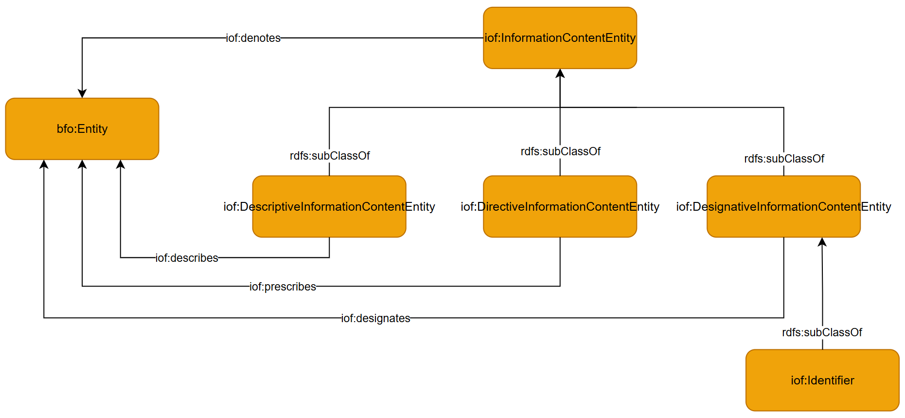
The core classes and relationships for modeling information. Different sub-properties of "is about" (designates, describes, prescribes) allow for precise modeling.
Use Case: Information About a Car
In this use case, various pieces of information about a car are asserted using the different "about-ness" relations to demonstrate their distinct meanings.
Use-Case Pattern Description
The diagram below applies the general pattern to a specific car instance (ns1:car1).
- The Entity (ns1:car1): An instance of iof:MaterialArtifact.
- Designation (ns1:car1-vin-number): The VIN iof:designates the car. As an iof:Identifier, it uniquely points to this one specific vehicle.
- Denotation (ns1:car1-model-name): The model name "Toyota Camry" iof:denotes the car. This name refers to the general model and is not unique to this single car.
- Description (ns1:car1-tagline): The marketing tagline iof:describes the car, providing qualitative, non-identifying information.
- Prescription (ns1:passenger-vehicle-specification): The GVWR standard iof:prescribes a regulatory requirement that the car must meet to be classified as a passenger vehicle.

Use Case Application
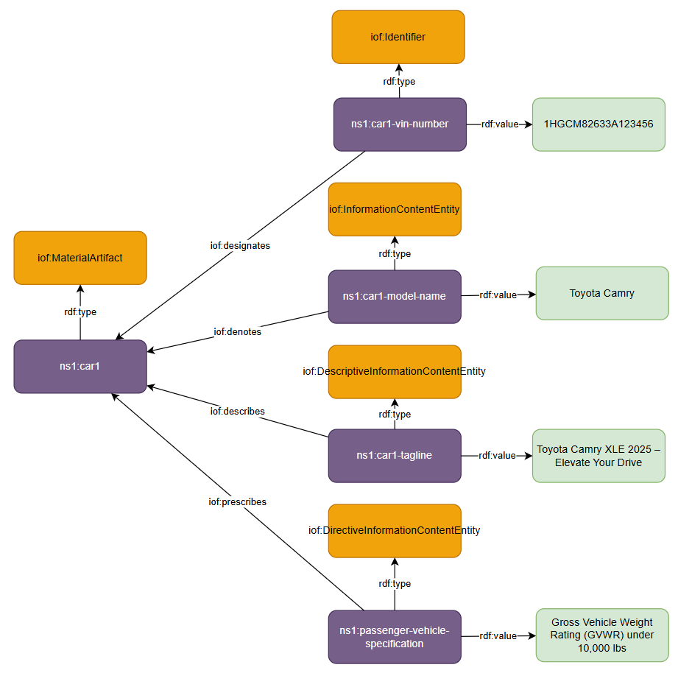
An example showing a single car (ns1:car1) connected to different types of information using the appropriate "about-ness" relations.

Pattern: Information Content, Bearers, and Their Subjects
Objective:
To model not just information as data values, but the complete semantic structure including what the information is about, how it's carried, and its various modes of reference. This pattern distinguishes between an entity as a real thing, information about that entity, and the physical or digital carriers of that information.
Scenario:
Consider a vehicle registration system. The vehicle itself is a physical object. Its VIN number is information that uniquely identifies it, stored in multiple databases and documents. The vehicle's description in a sales brochure provides characteristics without unique identification. The manufacturer's specifications prescribe how the vehicle should be built. This pattern allows us to model these layered, role-based information relationships.
Description:
This pattern builds on the concept of information aboutness and introduces the three-part structure from CCO.
- Real-World Entities (BFO:MATERIAL ENTITY): All subjects of information are real things. In the diagram, ns1:vehicle1 is an instance of VEHICLE (subclass of BFO:MATERIAL ENTITY).
- Information Content Entities: Information about the real-world entity, with different modes:
  - DESIGNATIVE ICE: Uniquely identifies the entity (e.g., ns1:vin1)
  - DESCRIPTIVE ICE: Describes characteristics (e.g., ns1:description1)
  - DIRECTIVE ICE: Prescribes requirements (e.g., ns1:specification1)
- Information Bearers: Physical or digital carriers of information:
  - ns1:dmv_database1: Database record containing VIN
  - ns1:sales_brochure1: Document containing description
  - ns1:spec_document1: Technical specification document
- Information Relationships: Three types of connections:
  - is_subject_of / designated_by: Links entity to identifying information
  - described_by: Links entity to descriptive information
  - prescribed_by: Links entity to prescriptive information
  - generically_depends_on: Links information content to its bearers
  - has_text_value: Links bearers to literal values
This structure allows us to query for "all information about vehicle X" (by looking at is_subject_of relationships) or "all databases containing this VIN" (by looking at the bearer relationships), which are two different but related questions.
Diagram: Multi-Modal Information Architecture
- Vehicle (center) connected to three types of ICE
- Each ICE connected to one or more bearers
- Bearers connected to literal values
- Different relationship types clearly labeled
Pattern: Measurement Information with Units
Objective:
To model measurements that capture qualities of entities, including the measurement process, units, and potential aggregation of multiple measurements.
Scenario:
Consider measuring a vehicle's fuel efficiency. Multiple test runs produce individual measurements, which are then averaged. Each measurement has a value and unit, is performed by specific equipment, and the aggregate provides the official rating.
Description:
This pattern extends the basic information pattern to handle measurements:
- Quality Attributes (BFO:QUALITY): Properties being measured
  - ns1:fuel_efficiency1: The vehicle's fuel efficiency quality
- Measurement Process (IOF:MEASUREMENT PROCESS):
  - ns1:test_run1, ns1:test_run2, ns1:test_run3: Individual measurement processes
  - has_participant: Links to measuring equipment
  - has_input: The quality being measured
  - has_specified_output: The measurement result
- Measurement Information (MEASUREMENT ICE):
  - ns1:measurement1, ns1:measurement2, ns1:measurement3: Individual results
  - is_measured_value_of: Links to the quality
  - uses_measurement_unit: Specifies the unit (e.g., MPG)
- Aggregation Process (IOF:COMPUTING PROCESS):
  - ns1:average_calculation1: Computes average from multiple measurements
  - has_input: Individual measurements
  - has_output: Aggregate value
Implementation Example:
# Vehicle with fuel efficiency measurements
ns1:vehicle1 a VEHICLE ;
iof:hasQuality ns1:fuel_efficiency1 .

# Individual measurement
ns1:test_run1 a iof:MeasurementProcess ;
iof:hasInput ns1:fuel_efficiency1 ;
iof:hasSpecifiedOutput ns1:measurement1 ;
bfo:hasParticipant ns1:test_equipment1 .

ns1:measurement1 a iof:MeasurementICE ;
iof:isMeasuredValueOf ns1:fuel_efficiency1 ;
iof:generically_depends_on ns1:test_record1 .

ns1:test_record1
cco:has_decimal_value "28.5" ;
cco:uses_measurement_unit qudt:MilesPerGallon .

# Aggregate calculation
ns1:average_calculation1 a iof:ComputingProcess ;
iof:hasInput ns1:measurement1, ns1:measurement2, ns1:measurement3 ;
iof:hasSpecifiedOutput ns1:official_mpg_rating .

Pattern: Multi-Source Information Resolution
Objective:
To model situations where identical information comes from multiple sources, ensuring proper resolution while maintaining provenance.
Scenario:
A person's birthdate "1990-01-15" is recorded in their passport, driver's license, and employer database. The information content is identical, but the bearers are different.
Description:
This pattern handles information resolution:
- Single Information Content Entity: One instance for identical content
  - ns1:birthdate1: Single DESCRIPTIVE ICE instance
- Multiple Bearers: Different sources carrying the same information
  - ns1:passport_page1: Physical passport page
  - ns1:license_record1: DMV database record
  - ns1:hr_database_entry1: Employer database
- Provenance Preservation: Each bearer maintains its own:
  - Source identification
  - Confidence ratings
  - Temporal validity
  - Access permissions
Key Principles:
- Resolve identical content to single ICE instances
- Preserve provenance through distinct bearers
- Track source-specific metadata on bearers, not content
This template structure works perfectly for information modeling patterns! It provides clear objectives, scenarios, detailed descriptions, and implementation examples - exactly what practitioners need to understand and apply the patterns correctly.

